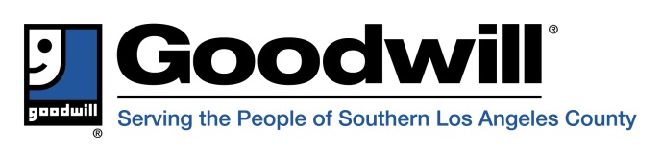
800 West Pacific Coast Highway
Long Beach, CA 90806-5299
Telephone: (562) 435-3411
TTY: (562) 590-8588
FAX: (562) 495-1447

FOR IMMEDIATE RELEASE Contact: Janet McCarthy
562.435.3411, ext. 222
jmccarthy@goodwillsolac.org

Goodwill Serving the People of Southern Los Angeles County
Hosts International Guests

Long Beach, CA -- Goodwill Serving the People of Southern Los Angeles County (Goodwill SOLAC) hosted international guests on Wednesday, August 22 and Thursday, August 24, 2018.
The delegation from Goodwill Korea spent the two days visiting store fronts, meeting with students and supported-employment work sites around the Southern Los Angeles County area.
Goodwill Korea's visit to Long Beach is part of an on-going effort to learn more about hiring people with disabilities in its retail stores and the larger community.
Janet McCarthy, President & CEO of Goodwill SOLAC said the visit provides an opportunity for the two organizations to learn from each other.
“It's always good to get a perspective outside of what we're used to, particularly internationally, and now we have some new friends halfway across the world”.
The information gathered by the delegation is expected to be shared with the Korean network aimed at raising awareness about disability rights in South Korea.
Goodwill SOLAC is a nonprofit organization that transforms donated goods into job training, education and placement services for individuals with barriers to employment. Goodwill SOLAC serves 22 cities and communities throughout Southern Los Angeles County. Goodwill SOLAC’s main facility—located at 800 W. Pacific Coast Highway in Long Beach—houses its administrative offices, training programs, processing operations, transportation fleet, LiNKS Sign Language & Interpreting Services, a retail store and shopgoodwill.com, its on-line retail store. To learn more about Goodwill career services or to find your nearest Goodwill store or donation center, visit www.ThinkGood.org.
# # #

